**DAILY ONLINE ACTIVITIES SUMMARY**

|  |  |  |  |  |  |  |  |  |
| --- | --- | --- | --- | --- | --- | --- | --- | --- |
| **Date:** | **19/06/2020** | | | | | **Name:** | **Hanan Saleem Baji** | |
| **Sem & Sec** | **4th SEM 'A' Section** | | | | | **USN:** | **4AL18CS024** | |
| **Online Test Summary** | | | | | | | | |
| **Subject** | | Microcontroller and Embedded System | | | | | | |
| **Max. Marks** | | 20 | | **Score** | | | 19 | |
| **Certification Course Summary** | | | | | | | | |
| **Course** | **1.Cloud Foundation** | | | | | | | |
| **Certificate Provider** | | | **1. Great Learning Academy** | | **Duration** | | | **1. 3 hour** |
| **Coding Challenges** | | | | | | | | |
| **Problem Statement:** 1. Write a C Program to Count total set bits in all numbers from 1 to n.  2. Write a C Program to rotate a Matrix by 90 Degree in Clockwise or Anticlockwise Direction. Implement (Both the rotations in single program using switch case statement).  3. Find the smallest positive integer value that cannot be represented as sum of any subset of a given array sorted in ascending order.  .  For example | | | | | | | | |
| **Status: completed** | | | | | | | | |
| **Uploaded the report in Github** | | | | | **Yes** | | | |
| **If yes Repository name** | | | | | 1. <https://github.com/saleemhananbaji/C-coding> 2. <https://github.com/saleemhananbaji/Java-coding> | | | |
| **Uploaded the report in slack** | | | | | **Yes** | | | |

ONLINE TEST DETAILS: Online test was conducted on fourth module of **Microcontroller and Embedded System**. Test contains 20 questions of 1 mark each. I have scored 19 Marks.

Snapshot:

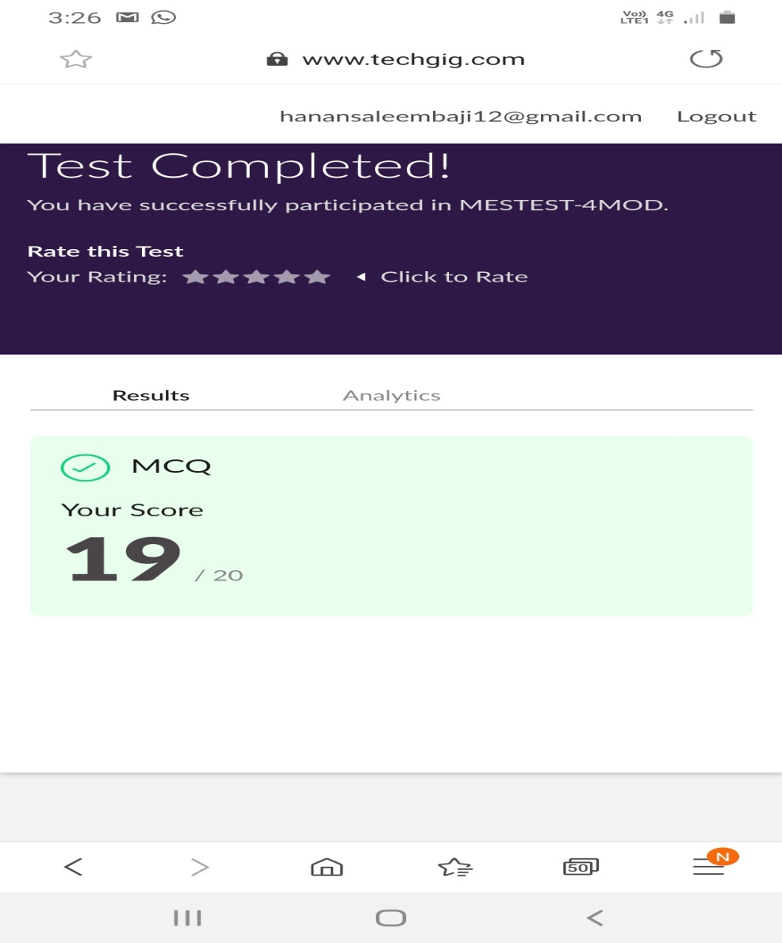

Certification Course Details: As the continuation of online course, I have completed Price Economics, Data Velocity, Distributed computing and Apps for cloud, Security Model.

Snapshot:





CODING CHALLENGES DETAILS: Problem statements

1. Write a C Program to Count total set bits in all numbers from 1 to n.

Solution: Uploaded it in github

Snapshot:

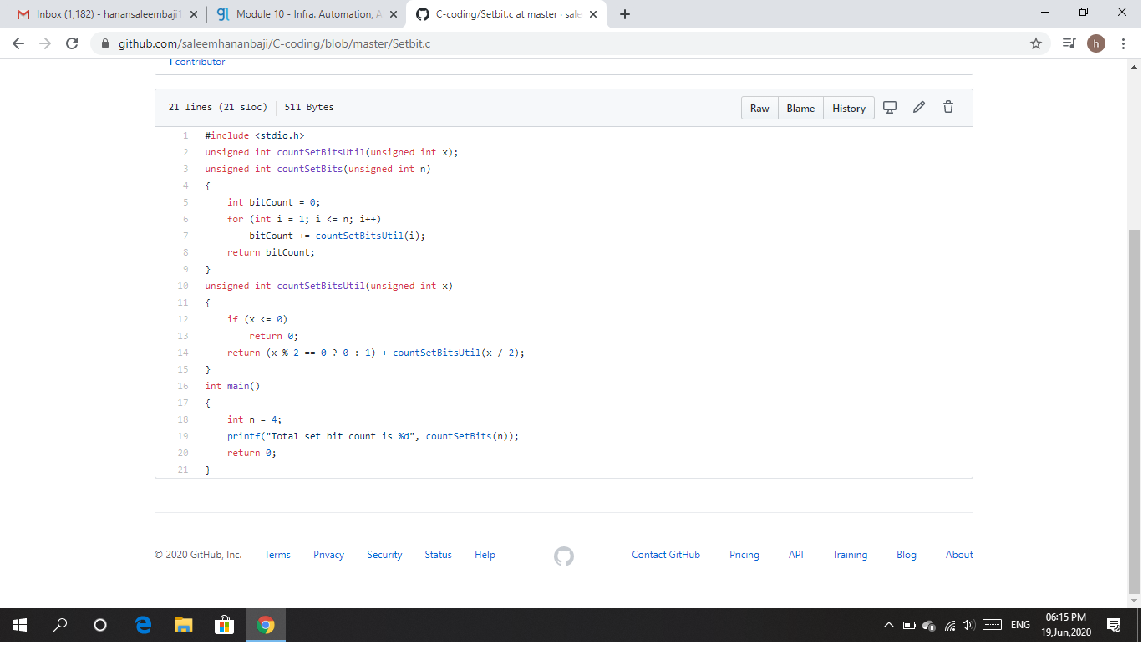

1. Write a C Program to rotate a Matrix by 90 Degree in Clockwise or Anticlockwise Direction. Implement (Both the rotations in single program using switch case statement).

Solution: Uploaded it in github

Snapshot:

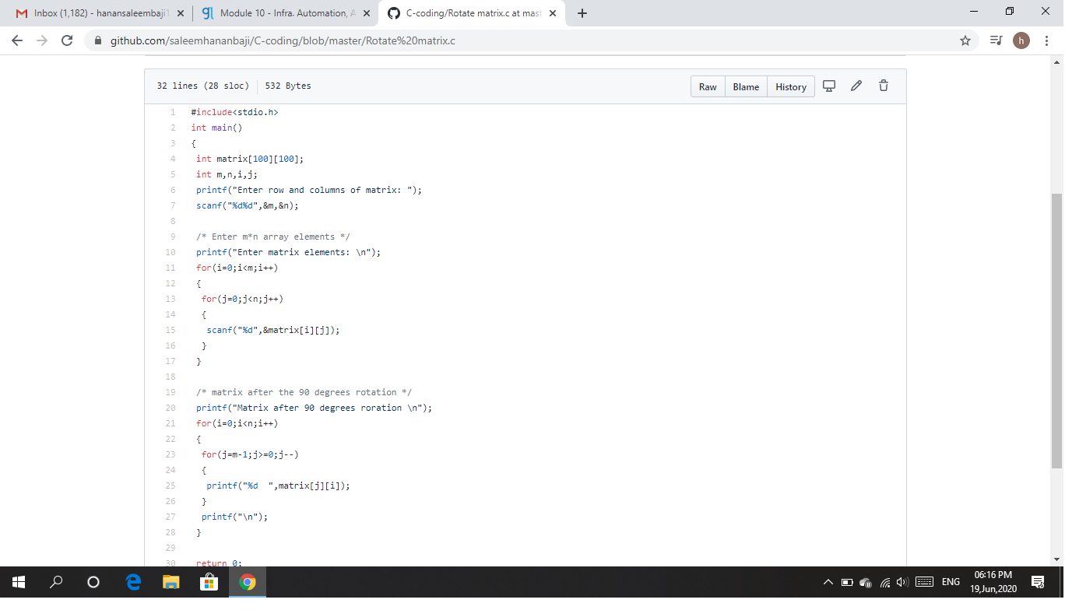

1. Find the smallest positive integer value that cannot be represented as sum of any subset of a given array sorted in ascending order.

Solution: Uploaded it in github

Snapshot:

